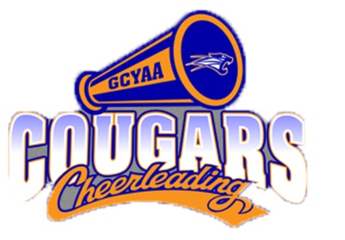
VOLUNTEER POLICY 2018

The success of our organization lies solely on the participation from the entire Cougar family. To maintain efficiency and order we rely on our parents. Each year it is mandatory that our parents volunteer their time during games and various events.

REQUIREMENTS:
For each child participating, at least one individual will be required to volunteer 3 full shifts with each shift being around 2 hours. (If you have more than 2 children in the program, you will be only required to volunteer a total of 6 shifts)
A $120 check made payable to GCYAA, postdated November 1, 2018 will be collected from each parent/guardian prior to equipment hand out day for football and the first practice for cheer. Cash will be accepted in lieu of a check. The check or cash deposit will be returned at the end of the season once all volunteering requirements have been met.

VOLUNTEER OPTIONS:
Volunteer date/time/options will be available through SignUp Genius and sent out to parents once schedules are determined. All volunteers MUST be 18 years of age or older. Additionally, it is your responsibility to sign the volunteer sheet prior to each shift to receive credit.

PENALTIES:
If the volunteer requirements are not met, the check will be cashed by the organization the week following the last game. Each volunteer shift has to be completed in its entirety or it will not count for a full shift, sometimes shifts can last longer than expected. Please understand that although the monetary donation is greatly appreciated, your volunteer time is much more valuable.

ACCEPTANCE OF CONTRACT:
By signing below, you acknowledge and agree to the terms of this contract, for the requirements set forth by the GCYAA Cougar Football & Cheer Organization.

_________________________________________________ ___________________
Parent/Guardian Signature Date

_________________________________________________ ___________________
Participant's Name Squad

